**SOFTWARE TRAINING REPORT**

**ON**

##### **NGO WEBSITE USING BOOTSTRAP**

*SUBMITTED IN PARTIAL FULFILMENT OF THE*

*REQUIREMENT FOR THE AWARD OF THE DEGREE* *OF*

**BACHELOR OF TECHNOLOGY IN**

# **COMPUTER SCIENCE & ENGINEERING**



***Submitted By:* Anant Saini**

***University Roll No:* 1726087**

***Submitted To:* Mr. Jagbir Singh Gill**

**Department of Computer Science & Technology**

**CGC COLLEGE OF ENGINEERING, LANDRA**



**Chandigarh Engineering College**, **Landran, Mohali**

**CANDIDATE’S DECLARATION**

I hereby certify that the work which is being presented in the report entitled Restaurant Management Systemin partial fulfilment for the award of the Degree of Bachelor of Technology in Computer Science and Engineering affiliated to **Punjab Technical University, Jalandhar** and submitted to the Department of Computer Science and Engineering of CGC Chandigarh Engineering College.

**Date: 17-12-2020 Name- Anant Saini**

**Roll no. 1726087**

This is to certify that the above statement made by the candidate is correct to the best of our knowledge

**Date: Head – CSE**

**ACKNOWLEDGMENT**

I take this opportunity to express my sincere gratitude to the principal CGC College of Engineering, Landran for providing this opportunity to carry out the present work.

I am highly grateful to the Dr. Manish Mahajan HOD CSE, CGC College of Engineering, Landran (Mohali), for providing this opportunity to carry out the six-month industrial training at **VOLKSWAGEN IT SERVICES INDIA PVT. LTD.** I would like to expresses my gratitude to other faculty members of Computer Science & Engineering department of CGC COLLEGE OF ENGINEERING, Landran for providing academic inputs, guidance & Encouragement throughout the training period. I would like to express a deep sense of gratitude and thank Mrs. Kavita Mam, with her guidance, it would have not been possible to pursue my training in this manner. Finally, I express my indebtedness to all who have directly or indirectly contributed to the successful completion of my industrial training.

**Anant Saini**

**1726087**

**COMPANY PROFILE**



**About Company**

VW IT Services India is the internal division of the VW Group offering digital solutions, application development and product innovation. We manage delivery, technology competencies, software assistance and process automation resources for the mobility domain. Envisaging a future as the best Software development and IT services organization in the Volkswagen Group.

VWITS is equipped with the latest competencies in: -

* Machine learning
* Cloud computing
* Artificial intelligence
* Java, SAP and Microsoft
* Block chain

The driving force behind the VWITS product innovation approach is the unit’s mission to cultivate a product-based organization with an entrepreneurial work culture that adds value to the automotive business. The journey started in 2010 when VW plant operations brought on board its first RCC employee for the K-SRM project. Soon, the RCC office building was approved and operations flourished with the onset of K-SRM AMS and MAN projects. In 2015, VW IT Services India was established as a separate IT entity with strategic goals for delivery, technology, processes, standards, compliance and finance. The VW-ITS arm was set in motion with the responsibility of serving Volkswagen and its subsidiaries within the VW group. Without technology partners, VW IT Services India has been successfully supporting development, sales and delivery for VW brands in all markets.

**History**

**1946** - Following the end of the war, the factory was put under British control. By the end of 1946, more than 10,000 cars were manufactured. A decade later, one million had been sold.

**1959** - Under the supervision of William Bernbach of the New York advertising agency Doyle Dane Bernbach (DDB), copywriters Julian Koenig and Helmut Krone created the now legendary "Think small" ad for Volkswagen with a tiny Beetle in a plane of white space. "Maybe we got so big because we thought small," the ad touted. Forty years later, Ad Age named it the best advertising campaign of the 20th century.

**1968** - The Type 1 was officially given the name "Beetle" (from "der Käfer," German for beetle, which was used in brochures). That year, Disney released the first of six movies featuring Herbie the Love Bug, an anthropomorphic 1963 Beetle with a racing-style number 53 on the hood. In 2018, one of the cars used in the 1977 movie Herbie Goes to Monte Carlo and 1982's Herbie Goes Bananas set a record for a Beetle at auction, selling at Barrett-Jackson for $128,700.

**1971** - Volkswagen introduced a premium model known as the Super Beetle. The car had a new front suspension and more trunk space—under the hood. The next year, on February 17, 1972, Beetle No. 15,007,034 rolled off the assembly line, surpassing the record held by the Ford Model T for four decades as the best-selling car in the world.

**1998** - Meet the New Beetle. After 60 years, VW gave the car its first major update with lines that recalled the Type 1 on what was basically a Volkswagen Golf platform. The car came with a 115-hp 2.0-liter four-cylinder engine, and in a nod to its flower-power roots, the dashboard had a small vase. The following year, Mike Myers drove a groovy version in Austin Powers: The Spy Who Shagged Me known as "The Shag Mobile."

**2018** - With sales having declined since 2013, Volkswagen announced that the Beetle had reached the end of the line. There will be two last models, the Final Edition SE (which starts at $25,995) and the Final Edition SEL (beginning at $29,995)—and both are available as convertibles. So is it really the last ride for the beloved Bug? As Hinrich J. Woebcken, president and CEO of Volkswagen Group of America, said in his announcement, "Never say never."

**Operations**

Rooted in Europe, the Volkswagen Group operates in 153 countries. [Volkswagen Passenger Cars](https://en.wikipedia.org/wiki/Volkswagen) is the Group's original marque, and the other major [subsidiaries](https://en.wikipedia.org/wiki/Subsidiary) include passenger car marques such as [Audi](https://en.wikipedia.org/wiki/Audi), [Bentley](https://en.wikipedia.org/wiki/Bentley), [Bugatti](https://en.wikipedia.org/wiki/Bugatti_Automobiles), [Lamborghini](https://en.wikipedia.org/wiki/Lamborghini), [Porsche](https://en.wikipedia.org/wiki/Porsche), [SEAT](https://en.wikipedia.org/wiki/SEAT), and Skoda. Volkswagen AG also has operations in [commercial vehicles](https://en.wikipedia.org/wiki/Commercial_vehicle), owning [Volkswagen Commercial Vehicles](https://en.wikipedia.org/wiki/Volkswagen_Commercial_Vehicles), along with controlling stakes in truck, bus and [diesel engine](https://en.wikipedia.org/wiki/Diesel_engine) manufacturers [Scania AB](https://en.wikipedia.org/wiki/Scania_(company)) and [MAN SE](https://en.wikipedia.org/wiki/MAN_SE).

**Ownerships**

Under the [Volkswagen Law](https://en.wikipedia.org/wiki/Volkswagen_Law), no shareholder in Volkswagen AG could exercise more than 20 percent of the firm's voting rights, regardless of their level of stock holding.[[78]](https://en.wikipedia.org/wiki/Volkswagen_Group#cite_note-79) This law was supposed to protect Volkswagen Group from takeovers.[[79]](https://en.wikipedia.org/wiki/Volkswagen_Group#cite_note-MT-80) In October 2005, [Porsche](https://en.wikipedia.org/wiki/Porsche) acquired an 18.53 percent stake in the business, and in July 2006, Porsche increased that ownership to more than 25 percent. Analysts disagreed as to whether the investment was a good fit for Porsche's strategy.[[80]](https://en.wikipedia.org/wiki/Volkswagen_Group#cite_note-81)

On 26 March 2007, after the [European Union](https://en.wikipedia.org/wiki/European_Union) moved against the Volkswagen law, Porsche took its holding to 30.9 percent, triggering a takeover bid under German law. Porsche formally announced in a press statement that it did not intend to take over Volkswagen Group, setting its offer price at the lowest possible legal value, but intended the move to avoid a competitor taking a large stake, or to stop hedge funds dismantling Volkswagen Group, which is Porsche's most important partner.[[81]](https://en.wikipedia.org/wiki/Volkswagen_Group#cite_note-82) On 16 September 2008, Porsche announced that the company had increased its stake in Volkswagen AG to 35 percent.[[82]](https://en.wikipedia.org/wiki/Volkswagen_Group#cite_note-83) By October 2008, Porsche held 42.6 percent of Volkswagen AG's [ordinary shares](https://en.wikipedia.org/wiki/Common_stock), and held [stock options](https://en.wikipedia.org/wiki/Option_(finance)) on another 31.5 percent.[[83]](https://en.wikipedia.org/wiki/Volkswagen_Group#cite_note-84) thus, effectively holding over 74 percent; 42.6 percent actual shares, and the rest as convertible options.[[84]](https://en.wikipedia.org/wiki/Volkswagen_Group#cite_note-85)  Porsche would get emergency infusion of about a billion dollars from Volkswagen.[[87]](https://en.wikipedia.org/wiki/Volkswagen_Group#cite_note-88) In July 2012, Volkswagen completed takeover of Porsche ending the 4 year saga and formed an integrated automotive group with Porsche. Porsche AG would become the 10th brand of Volkswagen. The holding company Porsche SE was left with 31 percent of the subscribed capital of Volkswagen AG, and 50.7 percent of the voting rights in the company.

**Stock Marketing Listings**

Volkswagen AG shares are primarily traded on the [Frankfurt Stock Exchange](https://en.wikipedia.org/wiki/Frankfurt_Stock_Exchange), and are listed under the 'VOW' and 'VOW3' [stock ticker symbols](https://en.wikipedia.org/wiki/Ticker_symbol). First listed in August 1961, the shares were issued at a price of [DM](https://en.wikipedia.org/wiki/Deutsche_Mark) 350 per DM 100 share, Volkswagen AG shares are now separated into two different types or classes: '[ordinary shares](https://en.wikipedia.org/wiki/Common_stock)' and '[preference shares](https://en.wikipedia.org/wiki/Preferred_stock). The ordinary shares are now traded under the [WKN](https://en.wikipedia.org/wiki/Wertpapierkennummer) 766400 and ISIN DE0007664005 listings, and the preference shares under the WKN 766403 and ISIN DE0007664039 listings.

Since the start of trading in 1961, Volkswagen AG shares have been subjected to two [stock splits](https://en.wikipedia.org/wiki/Stock_split) – the first was on 17 March 1969 when they were split at a ratio of 2:1, from a DM 100 share to a DM 50 share. The second split occurred on 6 July 1998, the DM 50 share being converted into a share of no overall nominal value, at a ratio of 1:10.

From 23 December 2009, Volkswagen AG preferred shares replaced its ordinary shares in the [DAX](https://en.wikipedia.org/wiki/DAX) index.

**Finance**

Volkswagen Finance Private Limited (‘VWFPL’), incorporated in 2009 and headquartered in Mumbai is jointly owned by Volkswagen Financial Services AG, Germany, and Volkswagen Finance Overseas BV, Netherlands.

Volkswagen Financial Services (‘VWFS’) AG is a 100% owned subsidiary of Volkswagen AG and has its headquarters in Braunschweig, Germany. VWFS AG is responsible for coordinating the worldwide financial services activities of the Volkswagen Group. More than 50 years ago VWFS AG financed the first Volkswagen vehicles. Since then, we have continuously expanded our scope of products.

VWFPL currently supports customers of the Volkswagen Group in India by facilitating delivery of innovative financing and insurance solutions.

With our comprehensive range of financial services products, we make a significant contribution to the promotion and securing of Volkswagen Group sales and strengthen the link between our customers and the Group brands. Metaphorically speaking our innovative financial services open our customers the door to their dream car - Volkswagen Financial Services: The key to mobility.

**TABLE OF CONTENTS**

|  |  |  |  |  |  |
| --- | --- | --- | --- | --- | --- |
|  | | **Title** | | | **Page No.** |
| 1. | | Introduction………………………………………………………  1.1 Objectives | | | 9 |
| 2. | | Web Development………………………………………………. | | | 10-12 |
|  | | 2.1 | | Web Site |  |
|  | | 2.2 | | Web Page |  |
| 3. | | The Steps to Create a Web site…………………………………… | | | 13-25 |
|  | | 3.1 | | UI development |  |
|  | | 3.1.1 HTML | | |  |
|  | | 3.1.2 CSS | | |  |
|  | | 3.1.3 Bootstrap | | |  |
|  | | 3.2 | | Scripting |  |
|  | | 3.2.1 Server-side scripting | | |  |
|  | | 3.2.2 Server-side scripting languages | | |  |
|  | | 3.2.3 Client-side scripting | | |  |
|  | | 3.3 | | Database |  |
|  | | 3.4 | | SQL |  |
|  | | 3.5 | | Queries |  |
| 4. | | Software Requirement Specification (SRS)………………….… | | | 26 |
|  | | 4.1 | | Hardware Requirement |  |
|  | | 4.2 | | Software Requirement |  |
| 5. | | Data Flow Diagram……………………………………………… | | | 27-28 |
|  | | 5.1 | | DFD-1 | |  |
|  | | 5.2 | | DFD-2 | |  |
|  | | 5.3 | | DFD-3 | |  |
| 6. | | Project……………………………………………………………. | | | | 29 |
|  | | 6.1 | | Project (Advanced Technologies) | |  |
|  | | 6.2 | | Technologies Used | |  |
|  | | 6.3 | | Technical details | |  |
| 7. | | Screenshots………………………………………………………. | | | | 30-36 |
| 8. | | Maintenance……………………………………………………… | | | | 37 |
| 9. | | Future scope and future enhancement…………………………… | | | | 38 |
| 10. | | Conclusion………………………………………………………. | | | | 39 |
|  | | Bibliography | | | |  |

**CHAPTER 1**

**INTRODUCTION**

A non-governmental organization (NGO) is any non-profit, voluntary citizens' group which is organized on a local, national or international level. They include many groups and institutions that are entirely or largely independent of government and that have primarily humanitarian or cooperative rather than commercial objectives. They are private agencies in industrial countries that support international development; indigenous groups organized regionally or nationally; and member-groups in villages. NGOs include charitable and religious associations that mobilize private funds for development, distribute food and family planning services and promote community organization. They also include independent cooperatives, community associations, water-user societies, women’s groups and pastoral associations. Citizen groups that raise awareness and influence policy are also NGOs”

* 1. **Objectives**

The purpose of this document is to systematically capture requirements for the project to be developed. Functional requirements of this system are captured in this document. It also serves as the input for the project scoping.

The scope of this document is limited to addressing the requirements from a user, quality, and non-functional perspective.

Confused on which course to take? I have got you covered. Browse courses and find.  
Code with Harry is my attempt to teach basics and those coding techniques to people in short time which took me ages to learn.

**CHAPTER-2**

**WEB-DEVELOPMENT:**

Web development is a broad term for the work involved in developing a web site for the Internet (World Wide Web) or an intranet (a private network). Web development can range from developing the simplest static single page of plain text to the most complex web-based internet applications, electronic businesses, and social network services. A more comprehensive list of tasks to which web development commonly refers, may include web engineering, web design, web content development, client liaison, client-side/side scripting, web server and network security configuration, and e-commerce development. Among web professionals, "web development" usually refers to the main non-design aspects of building web sites: writing markup and coding. Most recently Web development has come to mean the creation of content management systems or CMS. These CMS can be made from scratch, proprietary or open source. In broad terms the CMS acts as middleware between the database and the user through the browser. A principal benefit of a CMS is that it allows non-technical people to make changes to their web site without having technical knowledge.

For larger organizations and businesses, web development teams can consist of hundreds of people (web developers) and follow standard methods like Agile methodologies while developing websites. Smaller organizations may only require a single permanent or contracting developer, or secondary assignment to related job positions such as a graphic designer or information systems technician. Web development may be a collaborative effort between departments rather than the domain of a designated department. There are three kind of web developer specialization: front-end developer, back-end developer, and full-stack developer.

**2.1 WEB-SITE**

A website is a collection of related web pages, including multimedia content, typically identified with a common domain name, and published on at least one web server. A website may be accessible via a public Internet Protocol (IP) network, such as the Internet, or a private local area network (LAN), by referencing a uniform resource locator (URL) that identifies the site.

Websites have many functions and can be used in various fashions; a website can be a personal website, a commercial website for a company, a government website or a non-profit organization website. Websites are typically dedicated to a particular topic or purpose, ranging from entertainment and social networking to providing news and education. All publicly accessible websites collectively constitute the World Wide Web, while private websites, such as a company's website for its employees, and are typically a part of an intranet.

Web pages, which are the building blocks of websites, are documents, typically composed in plain text interspersed with formatting instructions of Hypertext Markup Language (HTML, XHTML). They may incorporate elements from other websites with

suitable markup anchors. Web pages are accessed and transported with the Hypertext Transfer Protocol (HTTP), which may optionally employ encryption (HTTP Secure, HTTPS) to provide security and privacy for the user. The user's application, often a web browser, renders the page content according to its HTML markup instructions onto a display terminal.

Hyperlinking between web pages conveys to the reader the site structure and guides the navigation of the site, which often starts with a home page containing a directory of the site web content. Some websites require user registration or subscription to access content. Examples of subscription websites include many business sites, news websites, academic journal websites, gaming websites, file-sharing websites, message boards, web-based email, social networking websites, websites providing real-time stock market data, as well as sites providing various other services. As of 2016 end users can access websites on a range of devices, including desktop and laptop computers, tablet computers, smartphones and smart TVs.

A web site consists of web pages which are interconnected to each other and contain various data and functionalities.

**2.2 WEB-PAGE**

A web page, or webpage, is a document that is suitable for the World Wide Web and web browsers. A web browser displays a web page on a monitor or mobile device. The web page is what displays, but the term also refers to a computer file, usually written in HTML or comparable markup language. Web browsers coordinate the various web resource elements for the written web page, such as style sheets, scripts, and images, to present the web page.

Typical web pages provide hypertext that includes a navigation bar or a sidebar menu to other web pages via hyperlinks, often referred to as links.

On a network, a web browser can retrieve a web page from a remote web server. On a higher level, the web server may restrict access to only a private network such as a corporate intranet or it provides access to the World Wide Web. On a lower level, the web browser uses the Hypertext Transfer Protocol (HTTP) to make such requests.

A static web page is delivered exactly as stored, as web content in the web server's file system, while a dynamic web page is generated by a web application that is driven by server- side software or client-side scripting. Dynamic website pages help the browser (the client) to enhance the web page through user input to the server.

**CHAPTER-3**

**THE STEPS TO CREATE A WEB SITE**

Creating a web site requires multiple steps which includes the following:

• Creating a UI (User interface)

• Scripting (Both at server end and client end)

• Creating a backend or the database

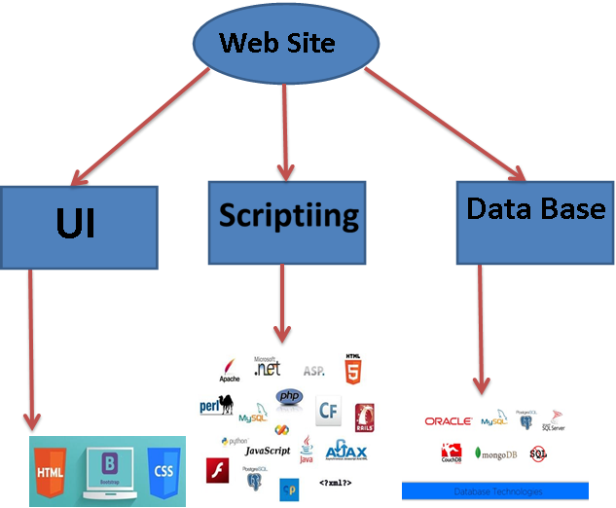

**Fig 3.1**

**3.1 UI DEVELOPMENT**

Technologies that are mostly used to develop a User Interface are:

• HTML

• CSS

• Bootstrap.

**3.1.1 HTML**

Hypertext Markup Language (HTML) is the standard markup language for creating web pages and web applications. With Cascading Style Sheets (CSS) and JavaScript it forms a triad of cornerstone technologies for the World Wide Web. Web browsers receive HTML documents from a webserver or from local storage and render them into multimedia web pages. HTML describes the structure of a web page semantically and originally included cues for the appearance of the document.

HTML elements are the building blocks of HTML pages. With HTML constructs, images and other objects, such as interactive forms, may be embedded into the rendered page. It provides a means to create structured documents by denoting structural semantics for text such as headings, paragraphs, lists, links, quotes and other items. HTML elements are delineated by tags, written using angle brackets. Tags such as <img /> and <input /> introduce content into the page directly. Others such as <p>...</p> surround and provide information about document text and may include other tags as sub-elements. Browsers do not display the HTML tags, but use them to interpret the content of the page.

HTML can embed programs written in a scripting language such as JavaScript which affect the behavior and content of web pages. Inclusion of CSS defines the look and layout of content. The World Wide Web Consortium (W3C), maintainer of both the HTML and the CSS standards, has encouraged the use of CSS over explicit presentational HTML since 1997.

HTML markup consists of several key components, including those called tags (and their attributes), character-based data types, character references and entity references. HTML tags most commonly come in pairs like <h1> and </h1>, although some represent empty elements and so are unpaired, for example <img>. The first tag in such a pair is the start tag, and the second is the end tag (they are also called opening tags and closing tags).

Another important component is the HTML document type declaration, which triggers standards mode rendering.

The following is an example of the classic Hello world program, a common test employed for comparing programming languages, scripting languages and markup languages. This example is made using 9 lines of code:

General Syntax of HTML

<!DOCTYPE html>

<html>

<head>

<title>This is a title</title>

</head>

<body>

<p>Hello world! </p>

</body>

</html>

(The text between <html> and </html> describes the web page, and the text between <body> and </body> is the visible page content. The markup text "<title>This is a title</title>" defines the browser page title.)

The Document Type Declaration <!DOCTYPE html> is for HTML5. If a declaration is not included, various browsers will revert to "quirks mode" for rendering.

**3.1.2 CSS**

Cascading Style Sheets (CSS) is a style sheet language used for describing the presentation of a document written in a markup language. Although most often used to set the visual style of web pages and user interfaces written in HTML and XHTML, the language can be applied to any XML document, including plain XML, SVG and XUL, and is applicable to rendering in speech, or on other media. Along with HTML and JavaScript, CSS is a cornerstone technology used by most websites to create visually engaging webpages, user interfaces for web applications, and user interfaces for many mobile applications.

CSS is designed primarily to enable the separation of presentation and content, including aspects such as the layout, colours, and fonts. This separation can improve content accessibility, provide more flexibility and control in the specification of presentation characteristics, enable multiple HTML pages to share formatting by specifying the relevant CSS in a separate .css file, and reduce complexity and repetition in the structural content.

Separation of formatting and content makes it possible to present the same markup page in different styles for different rendering methods, such as on-screen, in print, by voice (via speech-based browser or screen reader), and on Braille-based tactile devices. It can also display

the web page differently depending on the screen size or viewing device. Readers can also specify a different style sheet, such as a CSS file stored on their own computer, to override the one the author specified.

Changes to the graphic design of a document (or hundreds of documents) can be applied quickly and easily, by editing a few lines in the CSS file they use, rather than by changing markup in the documents.

The CSS specification describes a priority scheme to determine which style rules apply if more than one rule matches against a particular element. In this so-called cascade, priorities (or weights) are calculated and assigned to rules, so that the results are predictable.

The CSS specifications are maintained by the World Wide Web Consortium (W3C). Internet media type (MIME type) text/css is registered for use with CSS by RFC 2318 (March 1998). The W3C operates a free CSS validation service for CSS documents.

Types of CSS:

• Inline CSS:

In this CSS is applied in between the tags

Eg: <tag style=”styling”>Hello World</tag>

• Internal CSS:

In this Thecss code is defined inside the style tag in the head section of the HTML page.

General Syntax:

<html>

<head>

<style>

<! -- CSS STYLING -- >

</style>

</head>

</html>

• External CSS:

In this the CSS code is written on another page and is linked to the HTML page. It is advantageous to use this type of styling as we can use the same file to style various HTML pages.

External CSS uses the extension .css and is applied using the following syntax

<html>

<head>

<link relation=” stylesheet” type=”css” href=”url to the page”>

</head>

</html>

All the CSS style types are important but can be used in different situations.

• Inline CSS is used when only small changes are to be done to the HTML tag and the changes are to be reflected only to that specific tag

• Internal CSS is used when the individual HTML pages have to be designed differently. This also slows the page load system if the internal styling is long.

• External CSS files are maintained to design multiple pages and use common styles over various pages. It is useful as it helps in managing the resources in an easy manner.

Both HTML and CSS are used to create a UI but CSS behaves like a makeup on the face of an actress which makes her look even more beautiful than she is in reality.

##### **C:\Users\WIN8.1\Desktop\bf.pngBefore using CSS in**

##### **HTML page:**

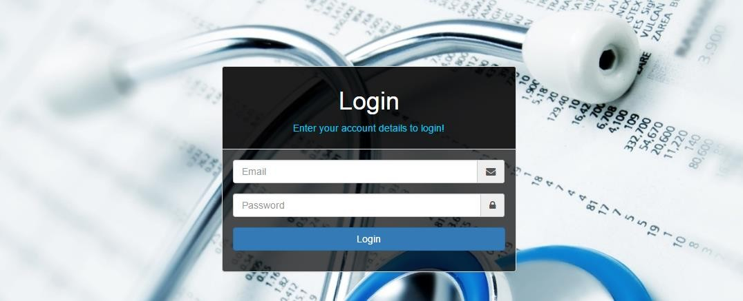

**After using CSS in**

**HTML Page:**

**3.1.3 BOOTSTRAP**

Bootstrap is a free and open-source front-end web framework for designing websites and web applications. It contains HTML- and CSS-based design templates for typography, forms, buttons, navigation and other interface components, as well as optional JavaScript extensions. Unlike many web frameworks, it concerns itself with front-end development only.

Bootstrap is the second most-starred project on GitHub, with more than 107,000 stars and 48,000 forks.

Bootstrap, originally named Twitter Blueprint, was developed by Mark Otto and Jacob Thornton at Twitter as a framework to encourage consistency across internal tools. Before Bootstrap, various libraries were used for interface development, which led to inconsistencies and a high maintenance burden. According to twitter developer Mark Otto:

“A super small group of developers and I got together to design and build a new internal tool and saw an opportunity to do something more. Through that process, we saw ourselves build something much more substantial than another internal tool. Months later, we ended up with an early version of Bootstrap as a way to document and share common design patterns and assets within the company.”

After a few months of development by a small group, many developers at Twitter began to contribute to the project as a part of Hack Week, a hackathon-style week for the Twitter development team. It was renamed from Twitter Blueprint to Bootstrap, and released as an open-source project on August 19, 2011. It has continued to be maintained by Mark Otto, Jacob Thornton, and a small group of core developers, as well as a large community of contributors.

On January 31, 2012, Bootstrap 2 was released, which added a twelve-column responsive grid layout system, inbuilt support for Glyph icons, several new components, as well as changes to many of the existing components.

On August 19, 2013, Bootstrap 3 was released, which redesigned components to use flat design, and a mobile first approach.

On October 29, 2014, Mark Otto announced that Bootstrap 4 was in development. The first alpha version of Bootstrap 4 was released on August 19, 2015.

Bootstrap 3 supports the latest versions of the Google Chrome, Firefox, Internet Explorer, Opera, and Safari (except on Windows). It additionally supports back to IE8 and the latest Firefox Extended Support Release (ESR).

Since 2.0, Bootstrap supports responsive web design. This means the layout of web pages adjusts dynamically, taking into account the characteristics of the device used (desktop, tablet, mobile phone).

Starting with version 3.0, Bootstrap adopted a mobile-first design philosophy, emphasizing responsive design by default.

The version 4.0 alpha release added Sass and flexbox support.

Installing and linking bootstrap to the HTML page:

• Install bootstrap from https://getbootstrap.com/

• Copy the bootstrap.min.css file to your CSS folder and link it to the HTML page in the similar manner to how any other CSS file is linked.

• Link the bootstrap.min.js file which is present in the JS folder of the bootstrap. It can be linked using script tag.

Eg: <script src=”url to bootstrap.min.js”></script>

• Now use bootstrap classes to reduce the work of designing which was earlier done through CSS.

**3.2 SCRIPTING**

There are two scripting methodologies.

1. Server-side scripting: This scripting is done at the server end

2. Client-side scripting: This scripting is done at the client end or the browser.

**3.2.1 SERVER-SIDE SCRIPTING**

Server-side scripting is a technique used in web development which involves employing scripts on a web server which produce a response customized for each user’s (client’s) request to the website. The alternative is for the web server itself to deliver a static web page. Scripts can be written in any of a number of server-side scripting languages that are available (see below). Server-side scripting is distinguished from client-side scripting where embedded scripts, such as JavaScript, are run client-side in a web browser, but both techniques are often used together.

Server-side scripting is often used to provide a customized interface for the user. These scripts may assemble client characteristics for use in customizing the response based on those characteristics, the user’s requirements, access rights, etc. Server-side scripting also enables the website owner to hide the source code that generates the interface, whereas with client-side scripting, the user has access to all the code received by the client. A down-side to the use of server-side scripting is that the client needs to make further requests over the network to the server in order to show new information to the user via the web browser. These requests can slow down the experience for the user, place more load on the server, and prevent use of the application when the user is disconnected from the server.

When the server serves data in a commonly used manner, for example according to the HTTP or FTP protocols, users may have their choice of a number of client programs (most modern web browsers can request and receive data using both of those protocols). In the case of more specialized applications, programmers may write their own server, client, and communications protocol that can only be used with one another.

Programs that run on a user’s local computer without ever sending or receiving data over a network are not considered clients, and so the operations of such programs would not be considered client-side operations.

**3.2.2 Server-Side scripting Languages**

There are several languages that can be used for server-side programming:

• PHP

• ASP.NET (C# OR Visual Basic)

• C++

• Java and JSP

• Python

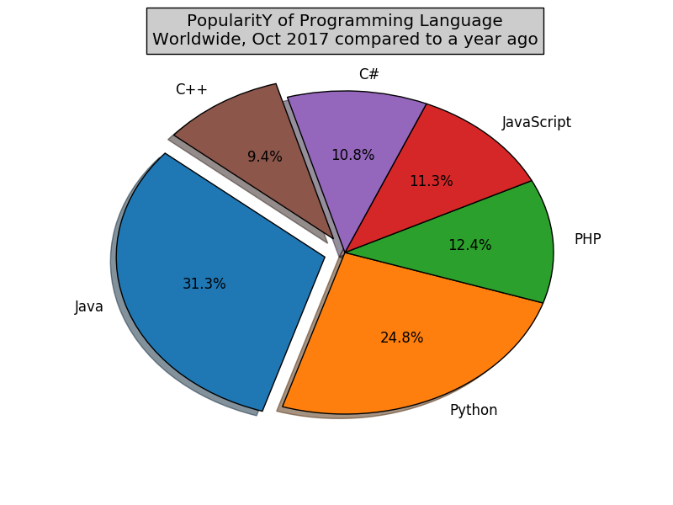• Ruby on Rails and so on.

**Fig 3.2.1**

**Fig 3.2.1**

**3.2.3 CLIENT-SIDE SCRIPTING**

Client-side scripting is changing interface behaviours within a specific web page in response to mouse or keyboard actions, or at specified timing events. In this case, the dynamic behaviour occurs within the presentation. The client-side content is generated on the user's local computer system.

Such web pages use presentation technology called rich interfaced pages. Client-side scripting languages like JavaScript or ActionScript, used for Dynamic HTML (DHTML) and Flash technologies respectively, are frequently used to orchestrate media types (sound, animations, changing text, etc.) of the presentation. Client-side scripting also allows the use of remote scripting, a technique by which the DHTML page requests additional information from a server, using a hidden frame, XML Http Requests, or a Web service.

The first widespread use of JavaScript was in 1997, when the language was standardized as ECMAScript and implemented in Netscape 3.

Example:

The client-side content is generated on the client's computer. The web browser retrieves a page from the server, then processes the code embedded in the page (typically written in JavaScript) and displays the retrieved page's content to the user.

The most popularly used client-side scripting languages is Java Script. Flow of request from browser to server:

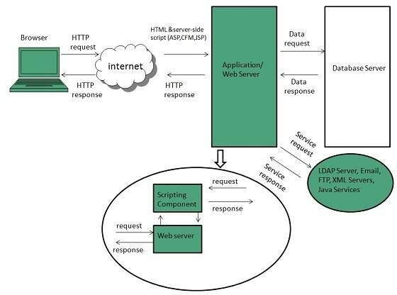

**Fig 3.2.2**

**3.3 DATABASE**

A database is an organized collection of data. It is the collection of schemas, tables, queries, reports, views, and other objects. The data are typically organized to model aspects of reality in a way that supports processes requiring information, such as modelling the availability of rooms in hotels in a way that supports finding a hotel with vacancies.

A database management system (DBMS) is a computer software application that interacts with the user, other applications, and the database itself to capture and analyse data. A general-purpose DBMS is designed to allow the definition, creation, querying, update, and administration of databases. Well-known DBMSs include MySQL, PostgreSQL, MongoDB, MariaDB, Microsoft SQL Server, Oracle, Sybase, SAP HANA, MySQL and IBM DB2. A

database is not generally portable across different DBMSs, but different DBMS can interoperate by using standards such as SQL and ODBC or JDBC to allow a single application to work with more than one DBMS. Database management systems are often classified according to the database model that they support; the most popular database systems since the 1980s have all supported the relational model as represented by the SQL language. Sometimes a DBMS is loosely referred to as a "database".

**3.4 SQL**

Originally based upon relational algebra and tuple relational calculus, SQL consists of a data definition language, data manipulation language, and data control language. The scope of SQL includes data insert, query, update and delete, schema creation and modification, and data access control. Although SQL is often described as, and to a great extent is, a declarative language (4GL), it also includes procedural elements.

SQL was one of the first commercial languages for Edgar F. Codd’s relational model, as described in his influential 1970 paper, "A Relational Model of Data for Large Shared Data Banks." Despite not entirely adhering to the relational model as described by Codd, it became the most widely used database language.

SQL became a standard of the American National Standards Institute (ANSI) in 1986, and of the International Organization for Standardization (ISO) in 1987. Since then, the standard has been revised to include a larger set of features. Despite the existence of such standards, most SQL code is not completely portable among different database systems without adjustments.

**3.5 QUERIES**

The most common operation in SQL, the query, makes use of the declarative SELECT statement. SELECT retrieves data from one or more tables, or expressions. Standard SELECT statements have no persistent effects on the database. Some non-standard implementations of SELECT can have persistent effects, such as the SELECT INTO syntax provided in some databases.

Queries allow the user to describe desired data, leaving the database management system (DBMS) to carry out planning, optimizing, and performing the physical operations necessary to produce that result as it chooses.

A query includes a list of columns to include in the final result, normally immediately following the SELECT keyword. An asterisk ("*") can be used to specify that the query should return all columns of the queried tables. SELECT is the most complex statement in SQL, with optional keywords and clauses that include:

• The FROM clause, which indicates the table(s) to retrieve data from. The FROM clause can include optional JOIN subclauses to specify the rules for joining tables.

• The WHERE clause includes a comparison predicate, which restricts the rows returned by the query. The WHERE clause eliminates all rows from the result set where the comparison predicate does not evaluate to True.

• The GROUP BY clause projects rows having common values into a smaller set of rows. GROUP BY is often used in conjunction with SQL aggregation functions or to eliminate duplicate rows from a result set. The WHERE clause is applied before the GROUP BY clause.

• The HAVING clause includes a predicate used to filter rows resulting from the GROUP BY clause. Because it acts on the results of the GROUP BY clause, aggregation functions can be used in the HAVING clause predicate.

• The ORDER BY clause identifies which column[s] to use to sort the resulting data, and in which direction to sort them (ascending or descending). Without an ORDER BY clause, the order of rows returned by an SQL query is undefined.

• The DISTINCT keyword eliminates duplicate data.

**CHAPTER-4**

**SOFTWARE REQUIREMENT SPECIFICATION**

**4.1 Hardware Requirements**

The selection of hardware is very important in the existence and proper working of any software. When selecting hardware, the size and requirements are also important.

|  |  |
| --- | --- |
| **Processor** | **Intel CORE i5** |
| RAM | **4.0 GB** |
| Hard Disk Drive | **500 GB** |

**4.2 Software Requirements**

|  |  |
| --- | --- |
| **Number** | **Description** |
| 1 | Windows 7,8,10 |
| 2 | HTML/CSS/Ajax/JavaScript/ Bootstrap. |
| 3 | Apache server/ XAMPSERVER |
| 4 | PHP 5.5.38 |
| 5 | MySQL |
| 6 | Compiler: MSVC11 (Visual C++ 2012) |
| 7 | Apache version: Apache/2.4.23 (Win32) OpenSSL/1.0.2h PHP/5.5.38 |

**CHAPTER-5**

**DATA FLOW DIAGRAM**

Data Flow Diagrams show the flow of data from external entities into the system, and from one process to another within the system. There are four symbols for drawing a DFD:

1. Rectangles representing external entities, which are sources or destinations of data.
2. Ellipses representing processes, which take data as input, validate and process it and output it.
3. Arrows representing the data flows, which can either, be electronic data or physical items.
4. Open-ended rectangles or a Disk symbol representing data stores, including electronic stores such as databases or XML files and physical stores such as filing cabinets or stacks of paper.

Figures below are the Data Flow Diagrams for the current system. Each process within the system is first shown as a Context Level DFD and later as a Detailed DFD. The Context Level DFD provides a conceptual view of the process and its surrounding input, output and data stores. The Detailed DFD provides a more detailed and comprehensive view of the interaction among the sub-processes within the system.

**CONTEXT LEVEL DAIGRAM**

**BROWSING**

**USER**

**EVENTS**

**Fig 5.1**

**FIRST LEVEL DFD**

**SEARCH EVENT**

**REGISTER**

**USER**

**Fig 5.2**

**SECOND LEVEL DFD**

**USER**

**CAUSE**

**SEARCH**

**DONATE**

**APPLY FILTERS**

**Fig 5.3**

**CHAPTER-6**

**PROJECT**

**6.1 PROJECT (Advanced Technologies):**

Name: Non – Governmental Website

**6.2 Technologies Used:**

* HTML
* CSS
* Bootstrap
* AJAX

**6.3 TECHNICAL DETAILS:**

* Front end is designed using HTML, CSS and Bootstrap. Ajax used to perform behind the screen requests and JavaScript used to perform client-side scripting
* Backend is based on PHP + MySQL based RDB (Relational Data Base) model.
* The SQL queries are run using the CI SQL library functions
* Backend online host includes a centralized database resident on the server, the script which is built in PHP used to SQL query the database on user’s request for transaction of data
* The forms are made using the HTML, Bootstrap for designing and Php, SQL for back-end

**CHAPTER-7**

**SCREENSHOT – FRONT PAGE**

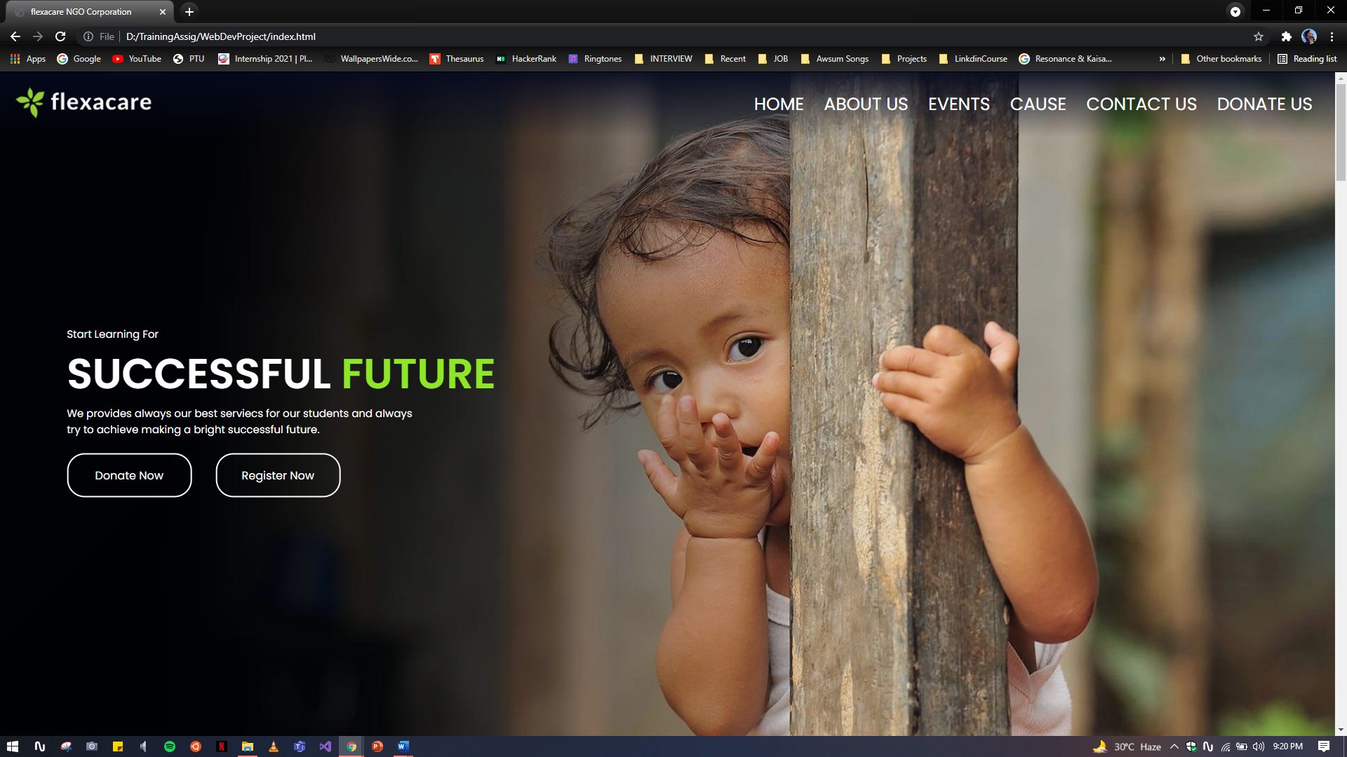

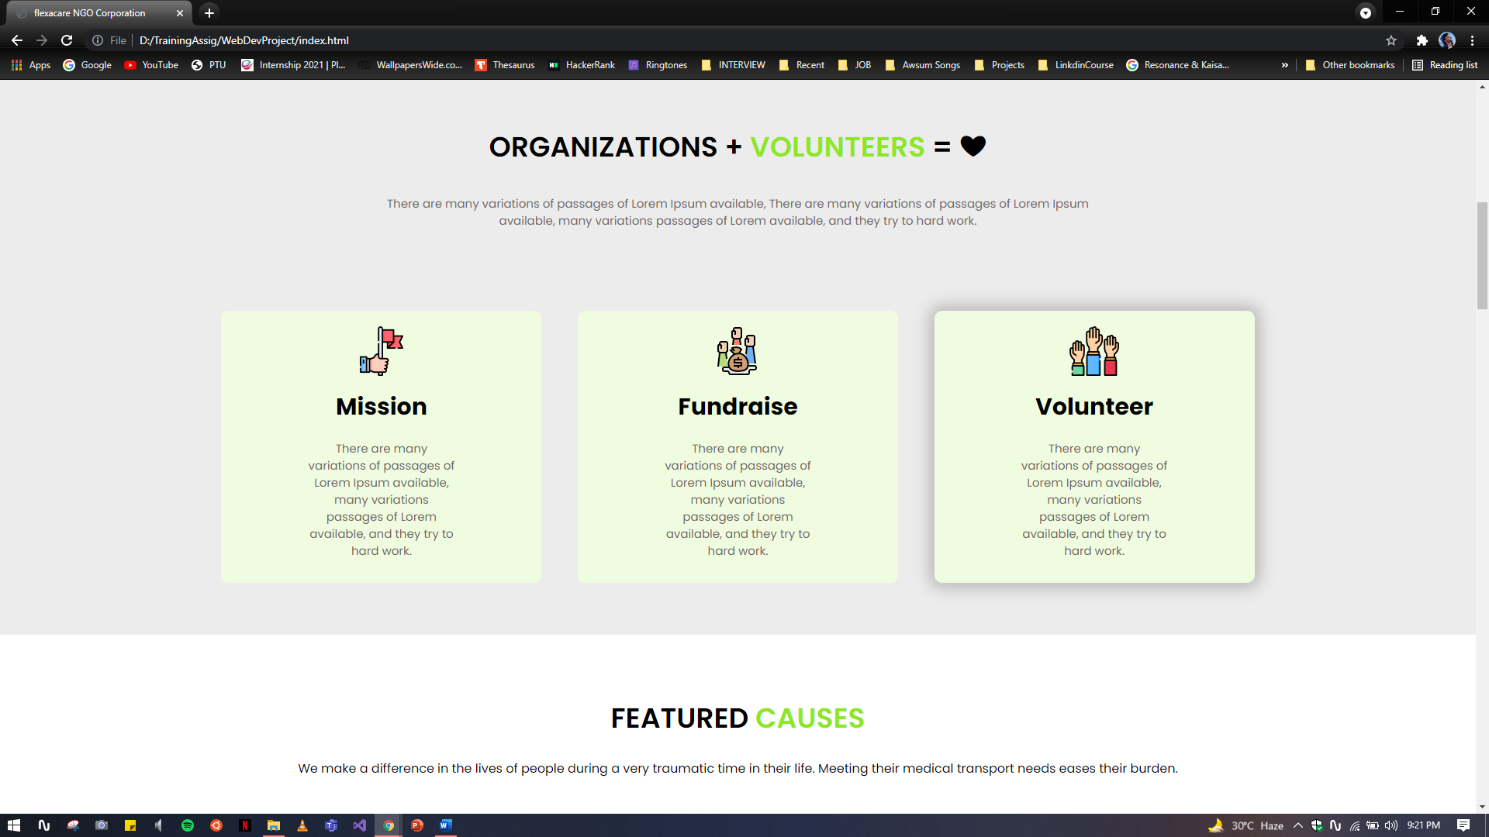

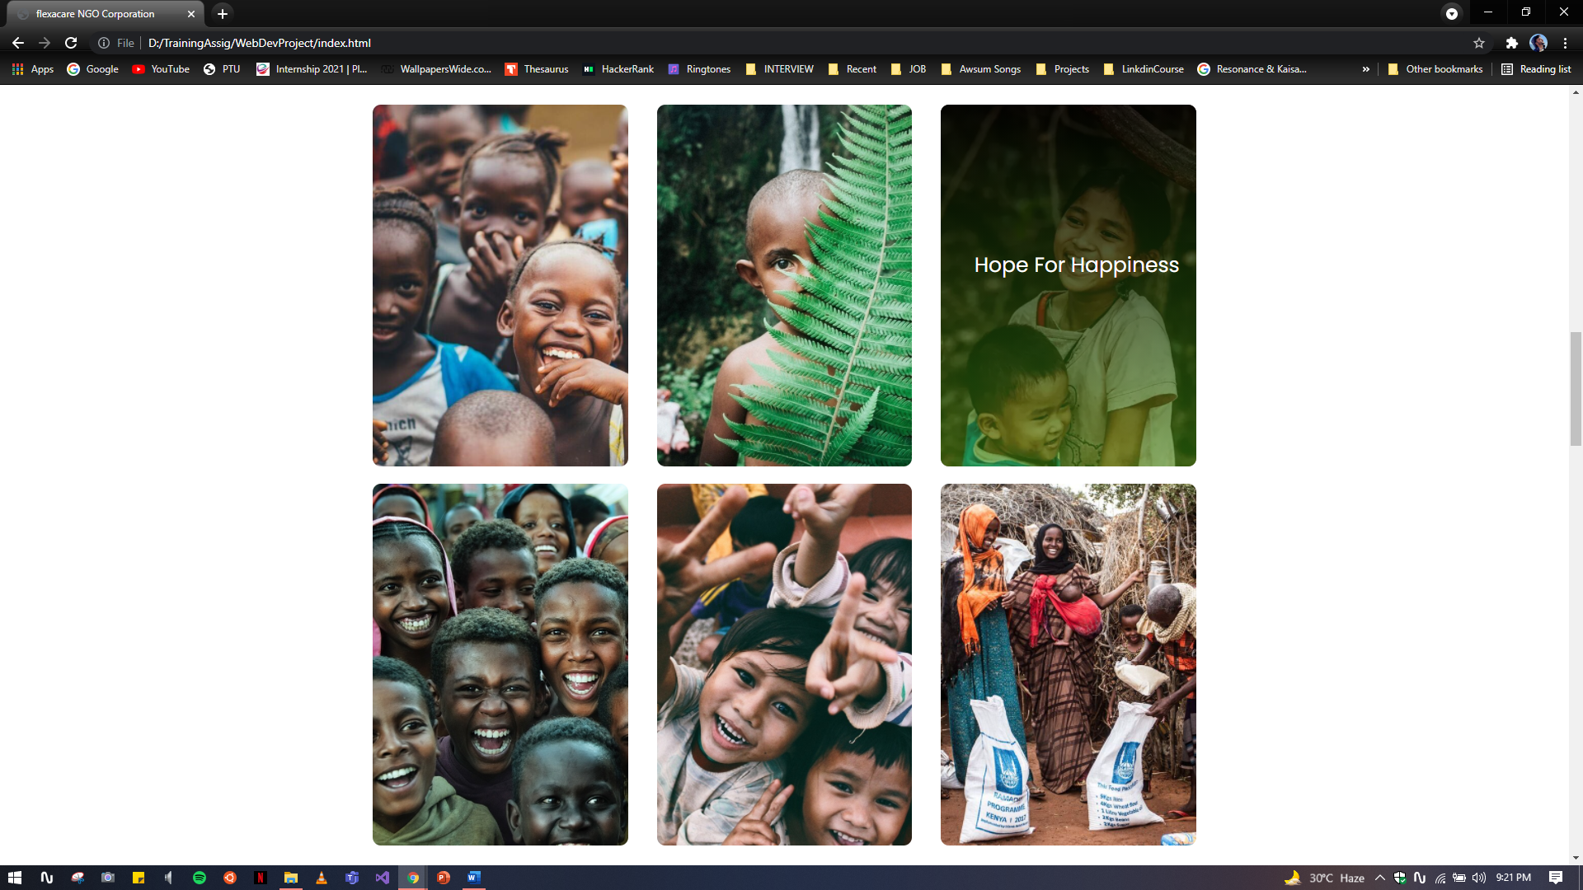

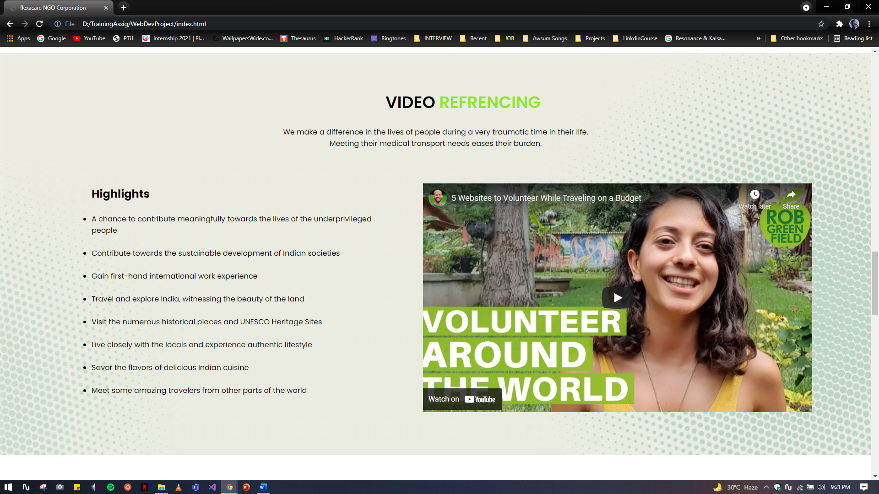

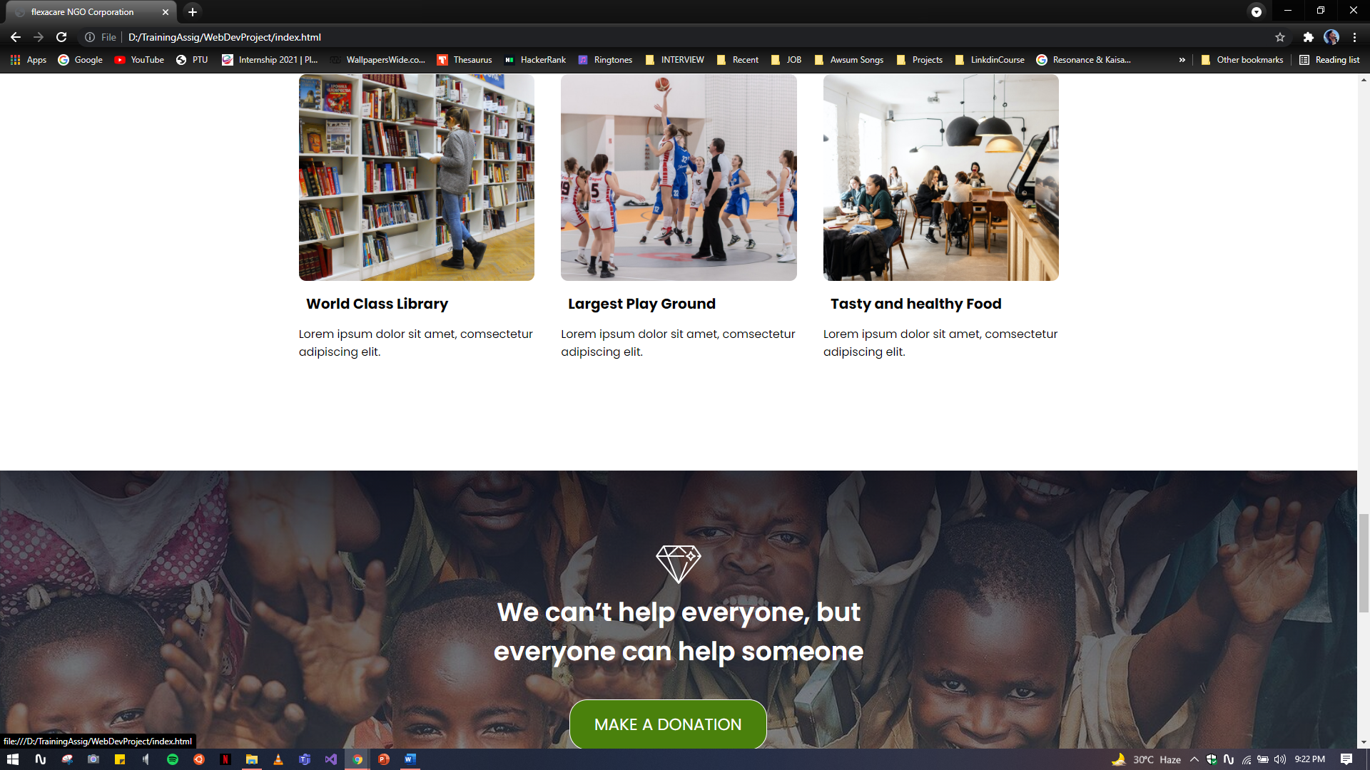

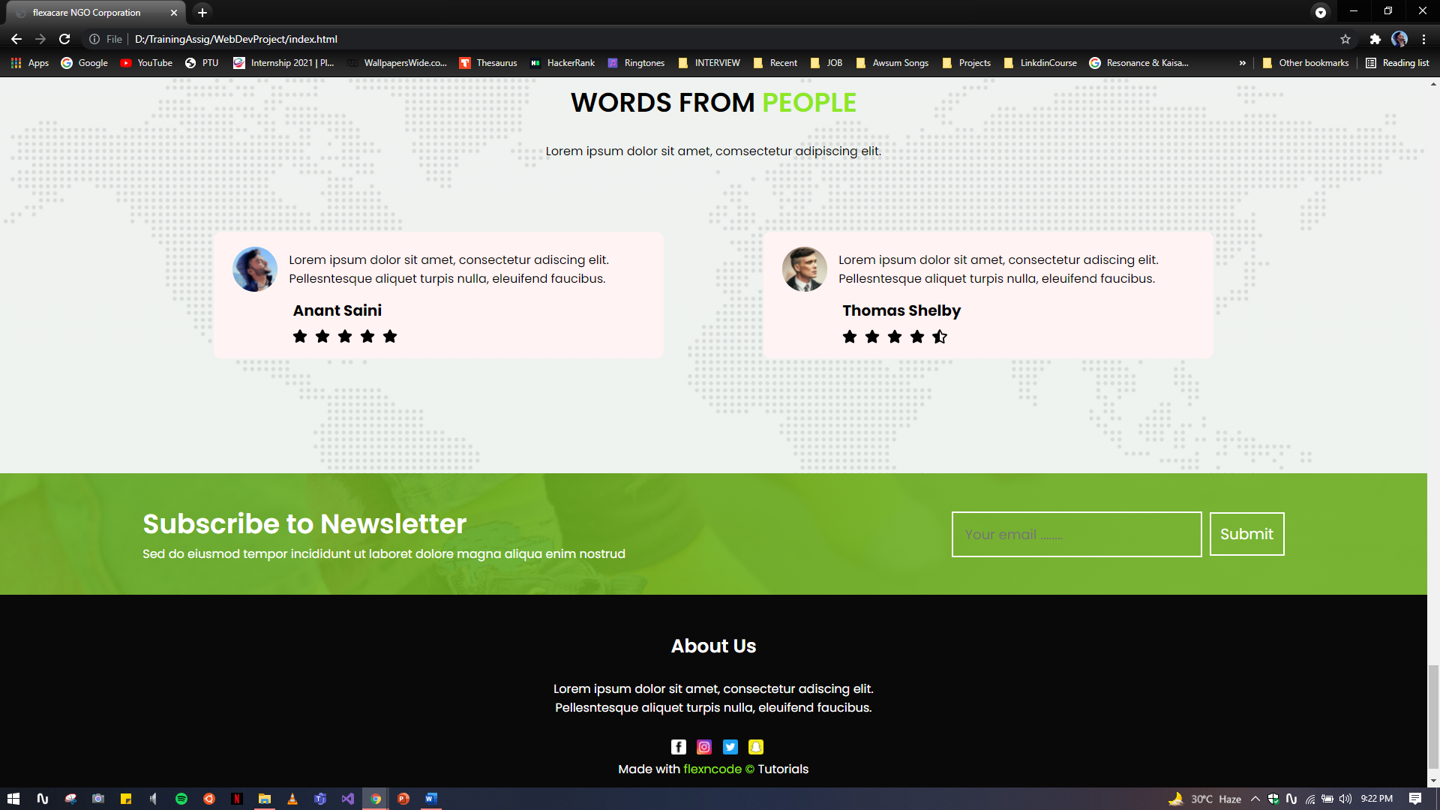

**SCREENSHOT – ABOUT US**

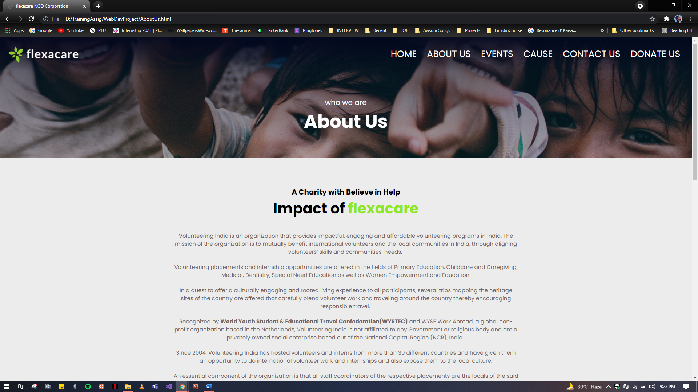

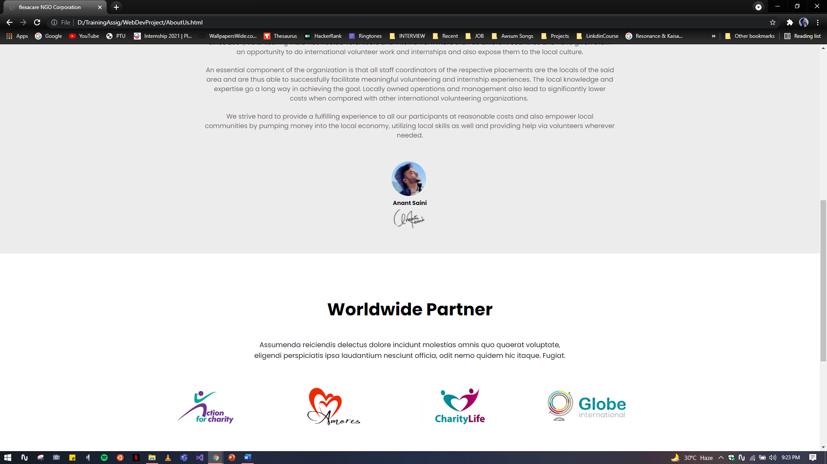

**SCREENSHOT – EVENTS**

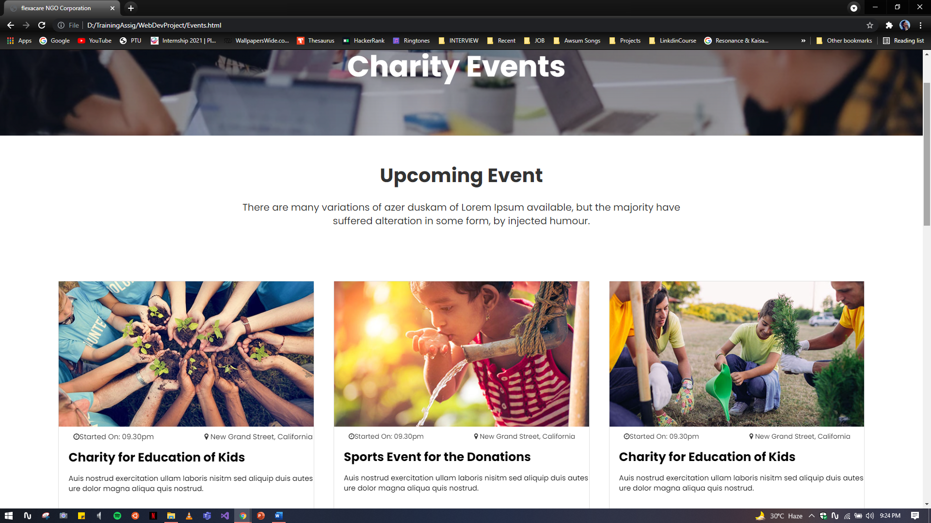

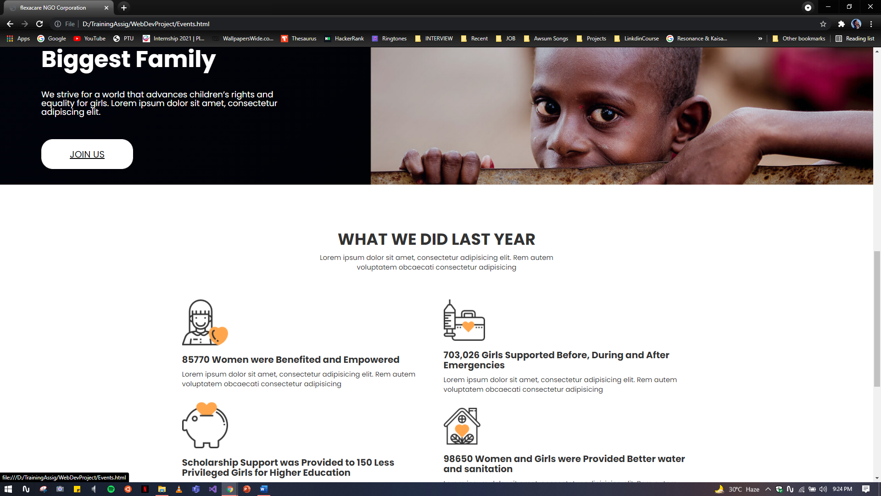

**SCREENSHOT – CAUSES**

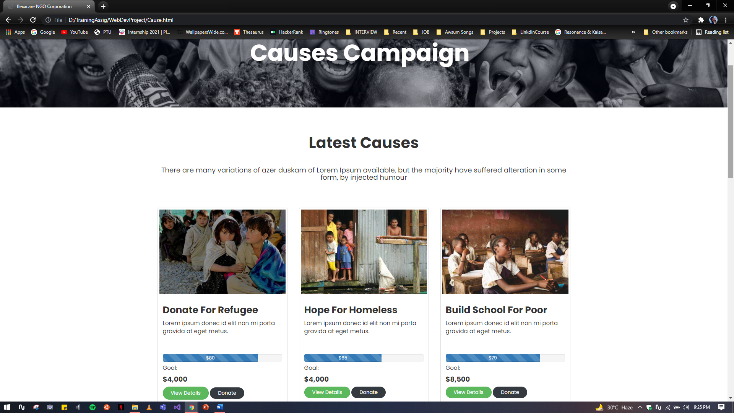

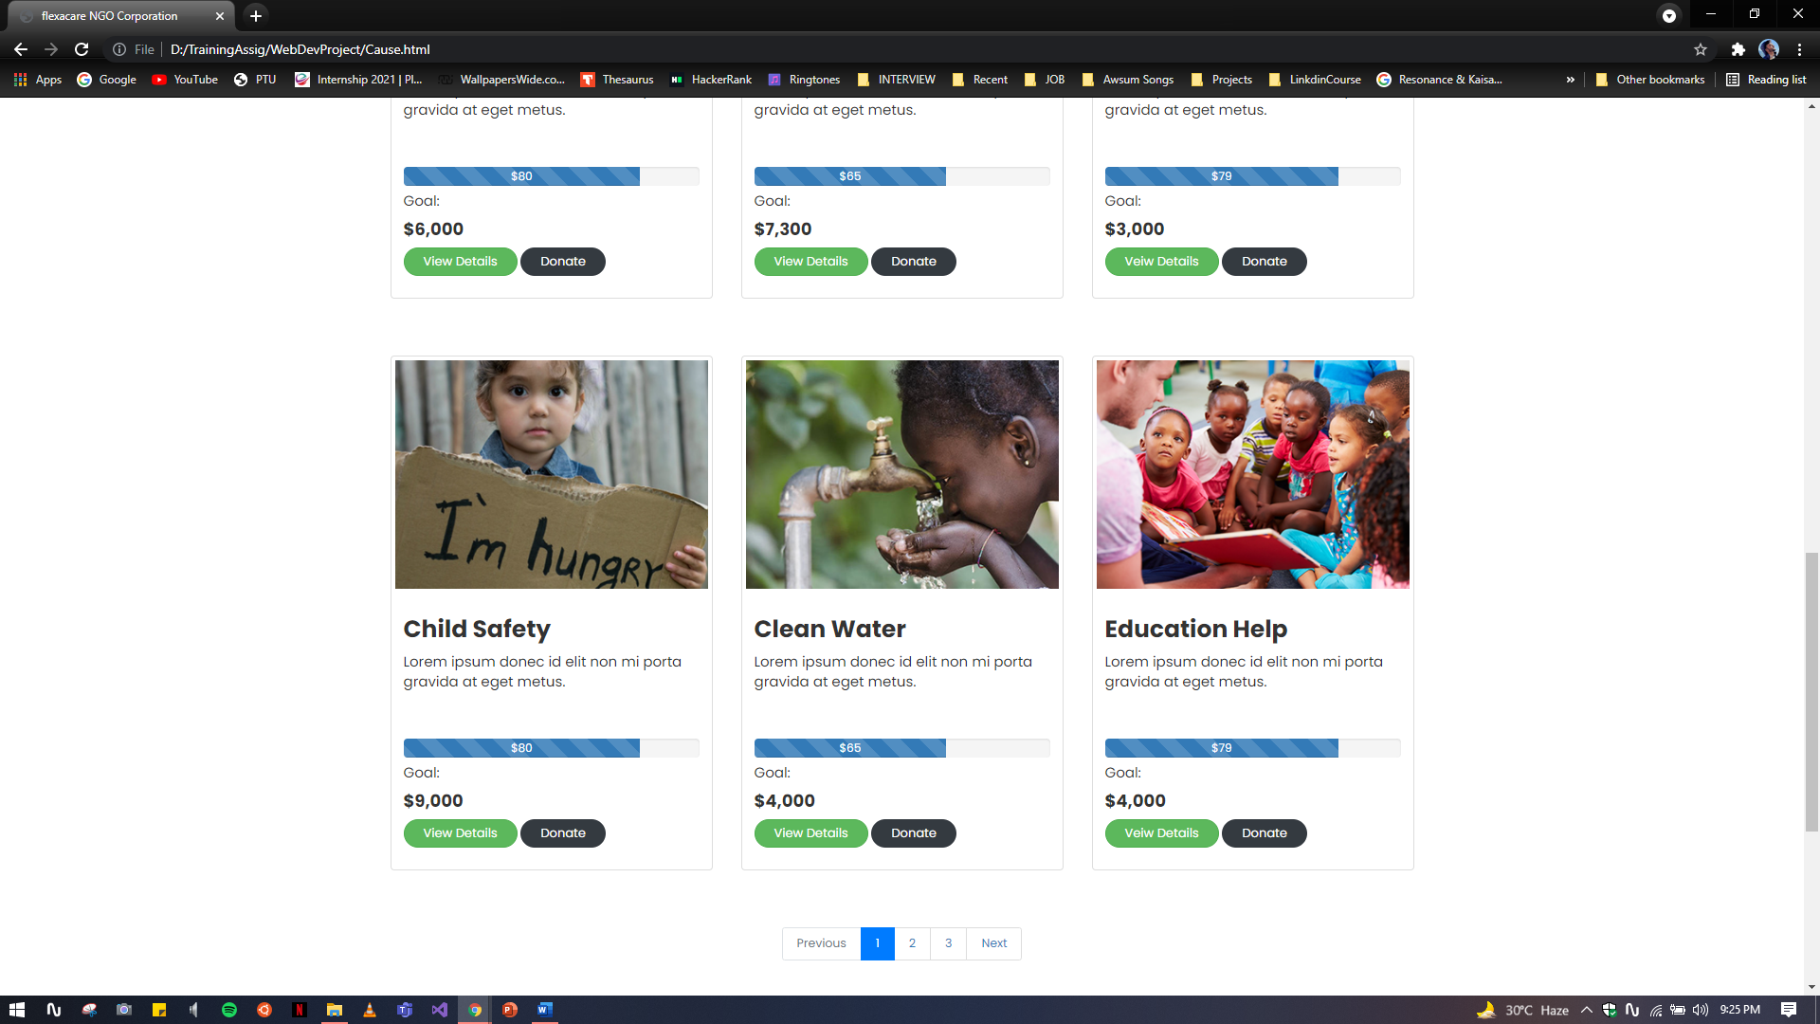

**SCREENSHOT – CONATCT US**

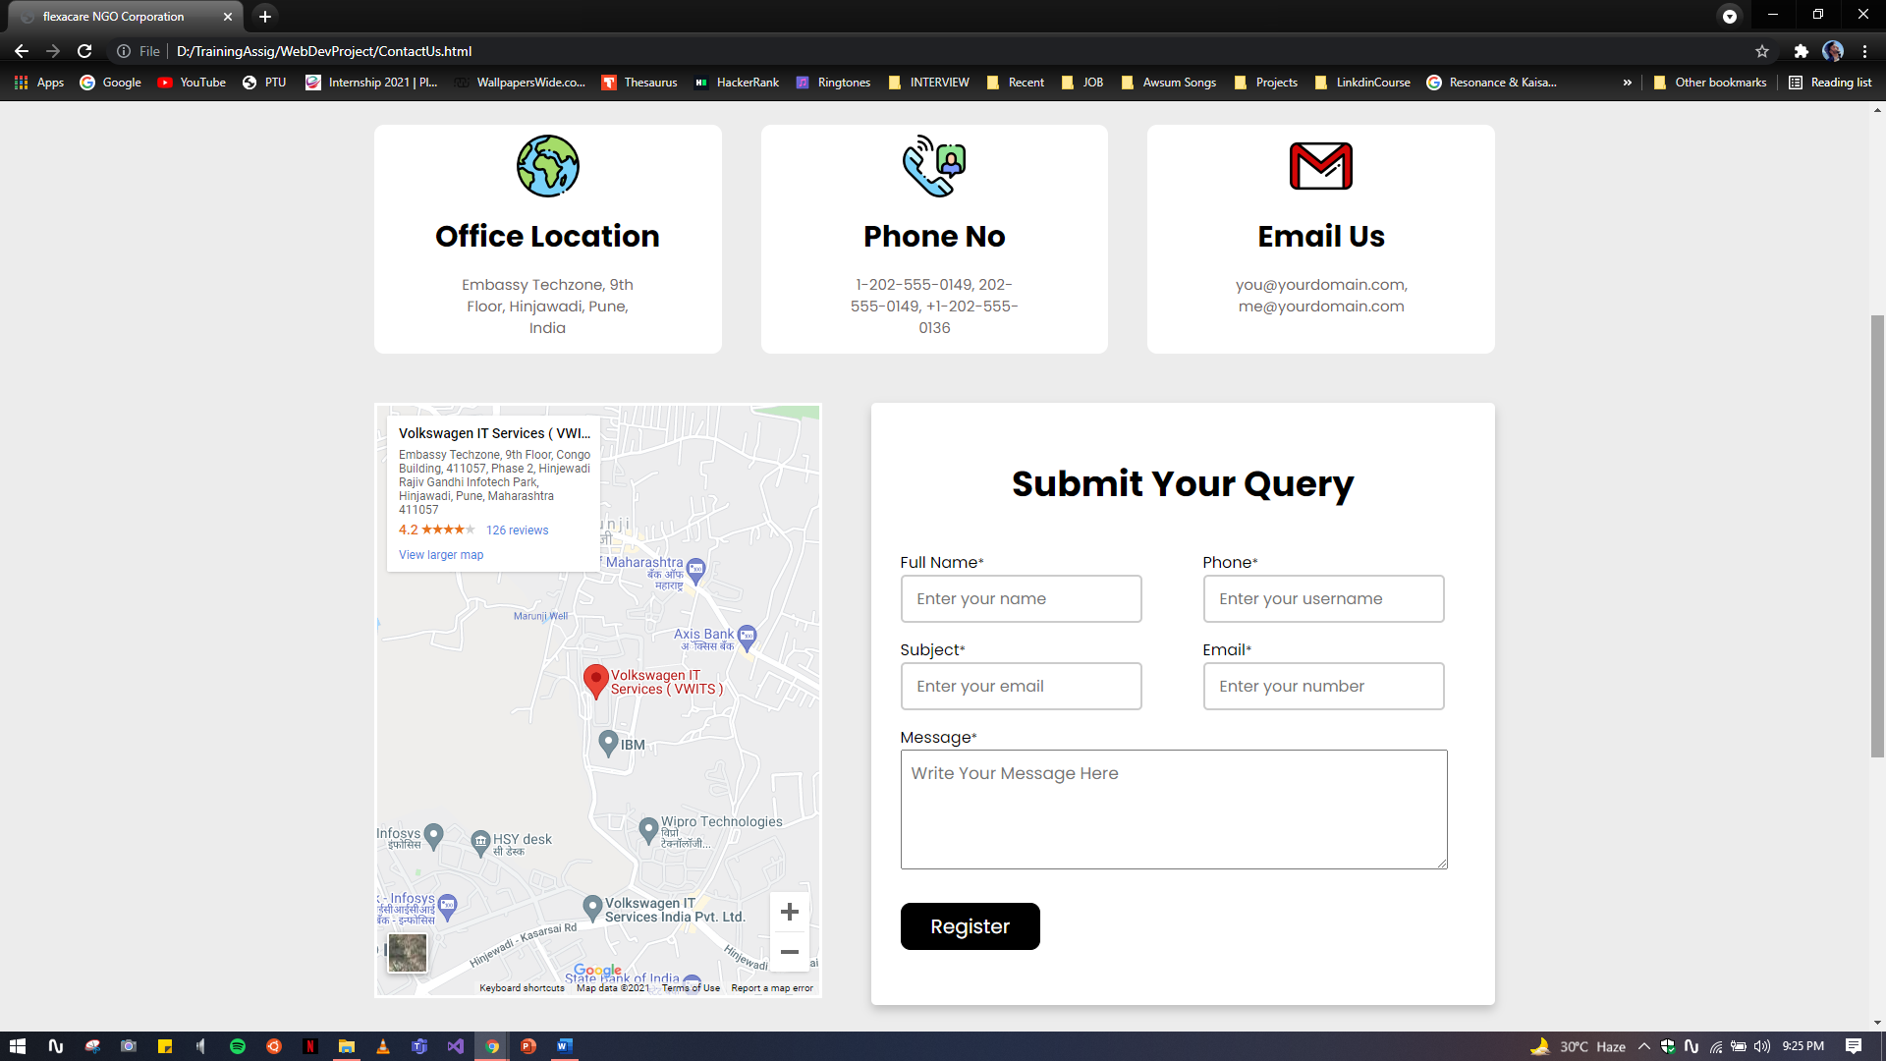

**CHAPTER-8**

**MAINTENANCE**

The maintenance phase involves making changes to hardware, software, and documentation to support its operational effectiveness. It includes making changes to improve a system’s performance, correct problems, enhance security, or address user requirements. To ensure modifications do not disrupt operations or degrade a system’s performance or security, organizations should establish appropriate change management standards and procedures.

Routine changes are not as complex as major modifications and can usually be implemented in the normal course of business. Routine change controls should include procedures for requesting, evaluating, approving, testing, installing, and documenting website modifications. Maintaining accurate, up-to-date hardware and software inventories is a critical part of all change management processes. Management should carefully document all modifications to ensure accurate system inventories. Management should coordinate all technology related changes through an oversight committee and assign an appropriate party responsibility for administering software patch management programs. Quality assurance, security, audit, regulatory compliance, network, and end-user personnel should be appropriately included in change management processes. Risk and security review should be done whenever a system modification is implemented to ensure controls remain in place.

For maintenance of the website:

1. The database has to be updated regularly according to new available information.
2. Redundant and false information must be removed from the database.
3. Newer version of PHP and MYSQL can be used for up gradation of website and to improve the overall performance of the system.

**CHAPTER-9**

**FUTURE SCOPE & FUTURE ENHANCEMENT**

**PROJECT NAME:**

**Non – Governmental Website**

1. It would allow you to set the event according to the date and location with the Geolocation Tag on it.
2. Virtual Events will be allowed which will be linked with many organizations and orphan society for their entertainment and education purpose.
3. E- Certificate of contribution will be generated to all the fundraiser.
4. Review of the Cause with the detail description and main cause behind it also the action that you can take against it.
5. Blogs will be added to the online website in order to see the previous sponsored event.

**CHAPTER-10**

**CONCLUSION**

The Fundamental objective of NGO is to act as catalyst in bringing about local, national and international initiative and community participation in overall improvement in quality of life and environment. It would also help the Government to obtain relevant information for promoting and facilitate the implementation of major environmental programs. The increase in the range of their activities reflects not only the increasing professionalism with which major groups are fulfilling their obligations and responsibilities. A number of public interest groups have also strengthened their participation at grassroots and community levels, and have played a vital role, not only in awareness-raising and campaigning, but also in education, training and capacity-building. Their activities show that they effectively use all media of communication, traditional as well as the new communication technologies, to disseminate information to the grassroots and to strengthen networking.

**BIBLIOGRAPHY**

1. www.javatutpoint.com

2. www.w3schools.com

3. www.getbootstrap.com

4. www.codeigniter.com

5. www.stackoverflow.com

6. www.fontawesome.io

7. Learn HTML and CSS faster (Mark Myers)